|  |  |
| --- | --- |
| C:\Users\Plasma-PC\Desktop\logo.jpg | **MINISTRY OF EDUCATION AND TRAINING** |

**FPT UNIVERSITY**

**Capstone Project Document**

**Olives**

Project Code: Olives  
Document Code: **Olives_PP_v1.0**

|  |  |  |
| --- | --- | --- |
| **Olives Team** | | |
| **Group member** | Phạm Đức Thắng | SE03055 |
| Trần Ánh Dương | SE02797 |
| Phạm Minh Tuấn | SE02875 |
| Bùi Quốc Trọng | SE03418 |
| Nguyễn Văn Hưng | SE02582 |
| Nguyễn Duy Linh | SE03150 |
| **Supervisor** | Lecturer: Phan Trường Lâm | |
| **Capstone Project code** | Olives | |

**Hoa Lac, 18th May 2016**

**CONTENT**

**1.** **Problem Definition** 2

1.1 Name of this Capstone Project 3

1.2 Problem Abstract 3

1.3 Project Overview 3

1.3.1 The Current System 3

1.3.2 The Proposed System 3

1.3.3 Boundaries of the System 3

1.3.4 Development Environment 3

**2.** **Project organization** 4

2.1 Software Process Model 4

2.2 Roles and Responsibilities 5

**3.** **Project Management Plan** 6

**3.1** **Task** 6

**3.2** **Project Schedule** 6

**3.3** **Meeting Minutes** 6

**4.** **Resource** 6

**5.** **Risk Management** 6

**6.** **Communication Management** 6

**9.** **Project Infrastructure** 8

9.1 Software and Techniques 8

9.2 Hardware 9

9.3 Other Infrastructure 9

**10.** **Coding convention** 9

**11.** **Version Numbering Rule** 9

**12.** **Directory Structure** 10

**13.** **Other Olives Rules** 11

1. **Introduction of SRS**
   1. Purpose

Software requirement specification outlines function and non-function requirements of the project called Olives, which is an application that helps people take care their health. It also provides some format constraints in common requirements and project success criteria. All members will work (design, code, test) based on the information provided in this document

* 1. Scope

Olives is an application that built on IOS platform and website application, in which people can track vitals & activity by connecting your favorite devices. Securely share your data with a Physician and receive better care.

* 1. Definitions, acronyms and abbreviations

|  |  |
| --- | --- |
| **Term** | **Definition** |
| **OL** | Olives |
| **Olives** | Name of the application, so does the project |
| **Admin** | Manage system |
| **Doctors** | People interact with the system |
| **Patients** | People interact with the system |
| **Guest** | People interact with the system |
| **Patient relationship manager** | People interact with the system |
| **Doctor relationship manager** | People interact with the system |

* 1. References

|  |  |  |
| --- | --- | --- |
| **No** | **Document** | **Source/Web Address** |
| 1 | System Requirements Specification Template | FPT Software Cop. |

* 1. Overview

The rest of the SRS contain 3 sections:

* **Introduction**: provides an overview of this document. It includes the purpose, scope, definitions, acronyms, abbreviations, references, and overview.
* **Overall Description**: describes the general factors that affect to the product and their requirements.
* **Specific Requirement**: Contains all requirements to a level of detail sufficient to help designers and testers satisfy those requirements.

1. **Overall description**
   1. Product perspective

Nowadays, the human health issues always are interested. But hospitals services can’t meet the needs of patients. Olives application is developed to help people take care their health with good doctors. Doctors reach larger populations without the traditional limitations. Grow your practice with more engaged care.

* 1. Product functions

2.2.1 Patient website application

* **View appointments**: Allow patients view all appointments with doctors
* **Add appointments**: Allow patients can create appointments
* **Accept appointments**: Allow patients accept appointments
* **Cancle appointments**: Allow patients can cancle appointments
* **View prescriptions**: Allow patients view all current prescriptions and history prescriptions
* **Add prescriptions**: Allow patients can create prescriptions
* **Delete prescriptions**: Allow patients can delete prescriptions
* **Edit prescriptions:** Allow patients can edit prescriptions
* **View medical records:** Allow patients can view medical records
* **Add medical records:** Allow patients can add medical records
* **Edit medical records:** Allow patients can edit medical records
* **Delete medical records:** Allow patients can delete medical records
* **View blood pressure index:** Allow patients can view blood pressure stats
* **Add blood pressure index:** Allow patients can add blood pressure index
* **Edit blood pressure index:** Allow patients can edit blood pressure index
* **Delete blood pressure index:** Allow patients can delete blood pressure index
* **View blood sugar index:** Allow patients can view blood sugar stats
* **Add blood sugar index:** Allow patients can add blood sugar index
* **Edit blood sugar index:** Allow patients can edit blood sugar index
* **Delete blood sugar index:** Allow patients can delete blood sugar index
* **View heartbeat index:** Allow patients can view heartbeat stats
* **Add heartbeat index:** Allow patients can add heartbeat index
* **Edit heartbeat index:** Allow patients can edit heartbeat index
* **Delete heartbeat index:** Allow patients can delete heartbeat index
* **Find doctors:** Allow patients can find doctors by name, specialty, country, city
* **Rate:** Allow patients can rate for their doctors
* **View profile:** All patients view their profile
* **Edit profile:** All patients edit their profile
* **Chat with doctors:** Allow patients chat with doctors

2.2.2 Doctors website application

* **View appointments**: Allow doctors view all appointments with patients
* **Add appointments**: Allow doctors can create appointments
* **Accept appointments**: Allow doctors accept appointments
* **Cancle appointments**: Allow doctors can cancle appointments
* **View prescriptions**: Allow doctors view all current prescriptions and history prescriptions
* **Add prescriptions**: Allow doctors can create prescriptions
* **Delete prescriptions**: Allow doctors can delete prescriptions
* **Edit prescriptions:** Allow doctors can edit prescriptions
* **View medical records:** Allow doctors can view medical records
* **Add medical records:** Allow doctors can add medical records
* **Edit medical records:** Allow doctors can edit medical records
* **Delete medical records:** Allow doctors can delete medical records
* **View blood pressure index:** Allow doctors can view blood pressure stats
* **View blood sugar index:** Allow doctors can view blood sugar stats
* **View heartbeat index:** Allow doctors can view heartbeat stats
* **View profile:** Allow doctors view their profile
* **Edit profile:** Allow doctors edit their profile
* **Create Diary:** Allow doctors create dairy
* **Edit Diary:** Allow doctors edit dairy
* **Delete Diary:** Allow doctors delete dairy
* **Chat with patients:** Allow doctors chat with patients

2.2.3 Patient Application

* **View appointments**: Allow patients view all appointments with doctors
* **Add appointments**: Allow patients can create appointments
* **Accept appointments**: Allow patients accept appointments
* **Cancle appointments**: Allow patients can cancle appointments
* **View prescriptions**: Allow patients view all current prescriptions and history prescriptions
* **Add prescriptions**: Allow patients can create prescriptions
* **Delete prescriptions**: Allow patients can delete prescriptions
* **Edit prescriptions:** Allow patients can edit prescriptions
* **View medical records:** Allow patients can view medical records
* **Add medical records:** Allow patients can add medical records
* **Edit medical records:** Allow patients can edit medical records
* **Delete medical records:** Allow patients can delete medical records
* **View blood pressure index:** Allow patients can view blood pressure stats
* **Add blood pressure index:** Allow patients can add blood pressure index
* **Edit blood pressure index:** Allow patients can edit blood pressure index
* **Delete blood pressure index:** Allow patients can delete blood pressure index
* **View blood sugar index:** Allow patients can view blood sugar stats
* **Add blood sugar index:** Allow patients can add blood sugar index
* **Edit blood sugar index:** Allow patients can edit blood sugar index
* **Delete blood sugar index:** Allow patients can delete blood sugar index
* **View heartbeat index:** Allow patients can view heartbeat stats
* **Add heartbeat index:** Allow patients can add heartbeat index
* **Edit heartbeat index:** Allow patients can edit heartbeat index
* **Delete heartbeat index:** Allow patients can delete heartbeat index
* **Find doctors:** Allow patients can find doctors by name, specialty, country, city
* **Rate:** Allow patients can rate for their doctors
* **Chat with doctors:** Allow patients chat with doctors
* **View profile:** All patients view their profile
* **Edit profile:** All patients edit their profile

2.2.4 Doctors application

* **View appointments**: Allow doctors view all appointments with patients
* **Add appointments**: Allow doctors can create appointments
* **Accept appointments**: Allow doctors accept appointments
* **Cancel appointments**: Allow doctors can cancel appointments
* **View prescriptions**: Allow doctors view all current prescriptions and history prescriptions
* **Add prescriptions**: Allow doctors can create prescriptions
* **Delete prescriptions**: Allow doctors can delete prescriptions
* **Edit prescriptions:** Allow doctors can edit prescriptions
* **View medical records:** Allow doctors can view medical records
* **Add medical records:** Allow doctors can add medical records
* **Edit medical records:** Allow doctors can edit medical records
* **Delete medical records:** Allow doctors can delete medical records
* **View blood pressure index:** Allow doctors can view blood pressure stats
* **View blood sugar index:** Allow doctors can view blood sugar stats
* **View heartbeat index:** Allow doctors can view heartbeat stats
* **Chat with patients:** Allow doctors chat with patients
* **View profile:** Allow doctors view their profile
* **Edit profile:** Allow doctors edit their profile
* **Create Diary:** Allow doctors create dairy
* **Edit Diary:** Allow doctors edit dairy
* **Delete Diary:** Allow doctors delete dairy

2.2.5 Admin website application

* **Active/De-active account:** Allow admin Active/De-active doctor’s account and patient’s account
* **Create catelogies:** Allow admin create catelogies of medical record
* **Edit catelogies:** Allow admin edit catelogies of medical record
* **Delete catelogies:** Allow admin delete catelogies of medical record
* **View profile:** Allow admin view doctor’s profile and patient’s profile

1. **Specification** **requirements**

This section describes about functional and non-functional requirement. The functional requirement includes use case diagram and use case description. The non-function requirement includes usability, reliability, and performance…requirement of the system.

3.1 Functional requirements

3.1.1 Use Case Diagram

3.1.2 Business Rule

3.1.3 Use Cases on Patient Application

3.1.3.1 Login

|  |  |  |  |
| --- | --- | --- | --- |
| UC ID and Name: | **UC-1.0.0 – Login** | | |
| Created By: | **DuongTA** | Date Created: | **16/6/2016** |
| Primary Actor: | **Patient** | Secondary Actors: | N/A |
| Trigger: | Actor navigates to [app]/patient | | |
| Description: | Authenticate and authorize the user. | | |
| Preconditions: | Actor has already have an account. | | |
| Post conditions: | Actor logins the system successfully | | |
| Normal Flow: | |  |  |  | | --- | --- | --- | | **No** | **Actor ‘s events** | **System response** | | 1 | Open application |  | | 2 |  | Display [login] screen | | 3 | Enter account details and click Login button. |  | | 4 |  | Display [Home] page. | | | |
| Alternative Flows: | N/A | | |
| Exceptions: | **Invalid email address**  1. System indicates that the email address entered is not valid  2. A message “Your email does not belong to an account. Please check and try again!”  3. Email can not empty. A message “Please enter you email” will appear **Invalid password**  1. System indicates that the password entered is not valid  2. A message “Your password is not correct. Please check and try again!”  3. Password can not empty. A message “Please enter you password” will appear | | |
| Priority: | High. | | |
| Frequency of Use: | High. | | |
| Business Rules: | N/A | | |
| Other Information: | N/A | | |
| Assumptions: | N/A | | |

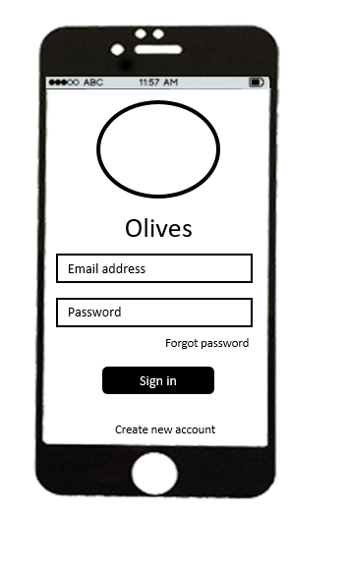

3.1.3.2 Register

|  |  |  |  |
| --- | --- | --- | --- |
| UC ID and Name: | **UC-1.0.0 – Register** | | |
| Created By: | **HungNV** | Date Created: | **16/6/2016** |
| Primary Actor: | **Patient** | Secondary Actors: | N/A |
| Trigger: | Actor navigates to [app]/patient | | |
| Description: | Register an account in Olives application. | | |
| Preconditions: | User access on [Login] Screen | | |
| Post conditions: | Olives registers and logs user in | | |
| Normal Flow: | |  |  |  | | --- | --- | --- | | **No** | **Actor ‘s events** | **System response** | | 1 | Open application |  | | 2 |  | Display [login] screen | | 3 | Click “Register” button. |  | | 4 |  | Display [Register] screen | | 5 | Enter account information details and click Save button. |  | | 6 |  | Back to [login] screen | | | |
| Alternative Flows: | N/A | | |
| Exceptions: | **Invalid email address:**  The system indicates a wrong E-mail address has been entered. A message “Your email address is not valid” will appear  **Invalid email address:**  Email can not empty  A message “Email can not empty” will appear **Duplicate Email address:** The system indicates this email address has been used. A message “Your email has been used! Please enter another one!”  **Password is to short:** The system indicates the entered invalid password A message “Your password is too short! Please input at least 8 characters!” will appear. **Password is not match:** The system indicates the entered invalid password A message “Your password do not matched” will appear.  **Invalid password:**  Password can not empty A message “Password can not empty” will appear  **Confirm Password is not match:** The system indicates the entered invalid password A message “Confirm password do not matched” will appear.  **Invalid First Name:** First Name can not empty  A message “First Name can not empty” will appear  **Invalid Last Name:** Last Name can not empty  A message “Last Name can not empty” will appear | | |
| Priority: | High. | | |
| Frequency of Use: | High. | | |
| Business Rules: | N/A | | |
| Other Information: | N/A | | |
| Assumptions: | N/A | | |

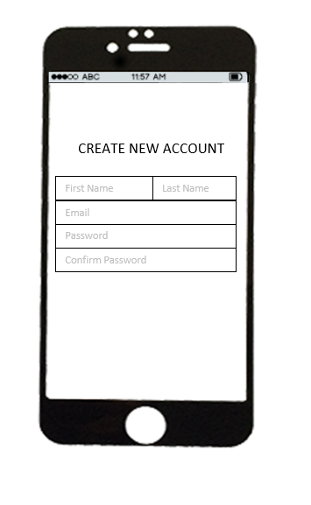

3.1.3.3 Forgot password

|  |  |  |  |
| --- | --- | --- | --- |
| UC ID and Name: | **UC-1.0.0 – Forgot password** | | |
| Created By: | **HungNV** | Date Created: | **16/6/2016** |
| Primary Actor: | **Patient** | Secondary Actors: | N/A |
| Trigger: | Actor navigates to [app]/patient | | |
| Description: | Get new password | | |
| Preconditions: | User access on [Login] Screen | | |
| Post conditions: | Login successful with new password | | |
| Normal Flow: | |  |  |  | | --- | --- | --- | | **No** | **Actor ‘s events** | **System response** | | 1 | Open application |  | | 2 |  | Display [login] screen | | 3 | Click “Forgot password” button. |  | | 4 |  | Display [Forgot password] screen | | 5 | Enter information and click “Send” button |  | | 6 |  | A message “Please check your email” will appear | | | |
| Alternative Flows: | N/A | | |
| Exceptions: | N/A | | |
| Priority: | High. | | |
| Frequency of Use: | High. | | |
| Business Rules: | N/A | | |
| Other Information: | N/A | | |
| Assumptions: | N/A | | |

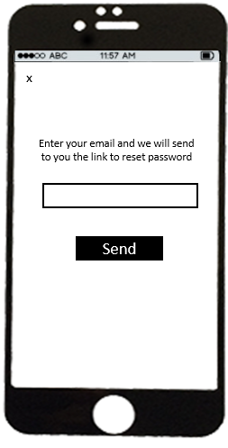

3.1.3.4 Change Password

|  |  |  |  |
| --- | --- | --- | --- |
| UC ID and Name: | **UC-1.0.0 – Change Password** | | |
| Created By: | **DuongTA** | Date Created: | **16/6/2016** |
| Primary Actor: | **Patient** | Secondary Actors: | N/A |
| Trigger: | Actor navigates to [app]/patient | | |
| Description: | Change password | | |
| Preconditions: | Actor has already have an account. | | |
| Post conditions: | Actor logins the system successfully | | |
| Normal Flow: | |  |  |  | | --- | --- | --- | | **No** | **Actor ‘s events** | **System response** | | 1 | Login to application |  | | 2 |  | Display [Home] screen | | 5 | Open menu tab and Click “Profile” button |  | | 6 |  | Display Profile page | | 7 | Click “Change password” button |  | | 8 |  | Display “Change password” page | | 9 | Enter password’s information (old password/ new password/ confirm password and click “Submit” button. |  | | 10 |  | Back to [Home] screen | | | |
| Alternative Flows: | N/A | | |
| Exceptions: | **Invalid old password**  1. System indicates that the old password entered is not valid  2. A message “Your password is not correct. Please check and try again!”  3. Old password can not empty. A message “Old password can not empty” will appear  **New password is to short:** The system indicates the entered invalid password A message “Your password is too short! Please input at least 8 characters!” will appear.  **New password invalid**: New password can not empty A message “New password can not empty” will appear  **Password is not match:** The system indicates the entered invalid password A message “Your password do not matched” will appear. | | |
| Priority: | High. | | |
| Frequency of Use: | High. | | |
| Business Rules: | N/A | | |
| Other Information: | N/A | | |
| Assumptions: | N/A | | |

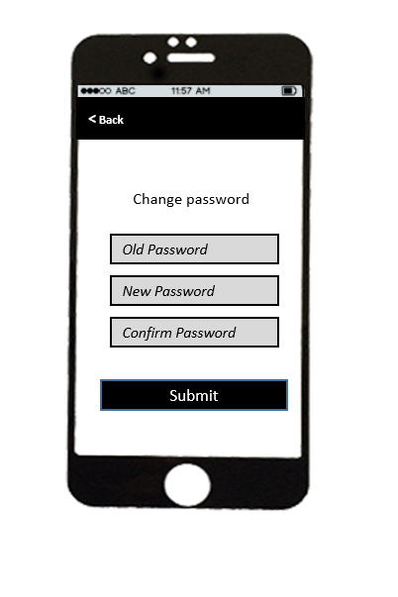

3.1.3.5 Notification

|  |  |  |  |
| --- | --- | --- | --- |
| UC ID and Name: | **UC-1.0.0 – Notification** | | |
| Created By: | **DuongTA** | Date Created: | **16/6/2016** |
| Primary Actor: | **Patient** | Secondary Actors: | N/A |
| Trigger: | Actor navigates to [app]/patient | | |
| Description: | View notification | | |
| Preconditions: | Actor has already have an account. | | |
| Post conditions: | Show all notification | | |
| Normal Flow: | |  |  |  | | --- | --- | --- | | **No** | **Actor ‘s events** | **System response** | | 1 | Login to application |  | | 2 |  | Display [Home] screen | | 5 | Click “Notification” icon |  | | 6 |  | Show all notification | | | |
| Alternative Flows: | N/A | | |
| Exceptions: | **N/A** | | |
| Priority: | High. | | |
| Frequency of Use: | High. | | |
| Business Rules: | N/A | | |
| Other Information: | N/A | | |
| Assumptions: | N/A | | |

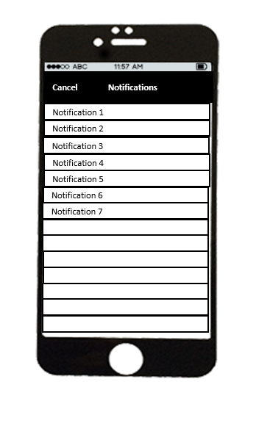

3.1.3.6 Find doctor

|  |  |  |  |
| --- | --- | --- | --- |
| UC ID and Name: | **UC-1.0.0 – Find doctor** | | |
| Created By: | **HungNV** | Date Created: | **16/6/2016** |
| Primary Actor: | **Patient** | Secondary Actors: | N/A |
| Trigger: | Actor navigates to [app]/patient | | |
| Description: | Find doctor | | |
| Preconditions: | User access on Login Screen successfully | | |
| Post conditions: | Show list all doctor | | |
| Normal Flow: | |  |  |  | | --- | --- | --- | | **No** | **Actor ‘s events** | **System response** | | 1 | Login to application |  | | 2 |  | Display [home] screen | | 3 | Click “Find doctor” button. |  | | 4 |  | Display [Find doctor] screen | | 5 | Click “Find” button |  | | 6 |  | Show list all doctor | | | |
| Alternative Flows: | N/A | | |
| Exceptions: | **N/A** | | |
| Priority: | High. | | |
| Frequency of Use: | High. | | |
| Business Rules: | N/A | | |
| Other Information: | N/A | | |
| Assumptions: | N/A | | |

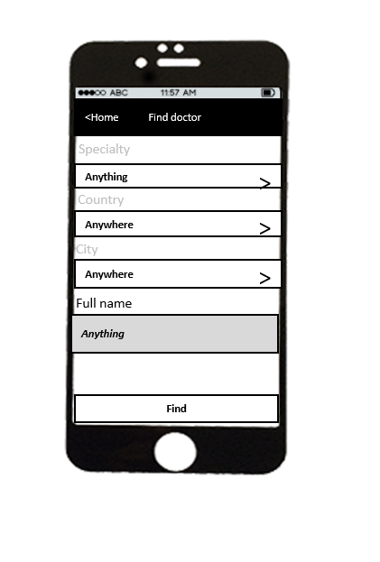

3.1.3.7 My doctor

|  |  |  |  |
| --- | --- | --- | --- |
| UC ID and Name: | **UC-1.0.0 – My doctor** | | |
| Created By: | **HungNV** | Date Created: | **16/6/2016** |
| Primary Actor: | **Patient** | Secondary Actors: | N/A |
| Trigger: | Actor navigates to [app]/patient | | |
| Description: | Show my doctor | | |
| Preconditions: | User access on Login Screen successfully | | |
| Post conditions: | Diplay all my doctor | | |
| Normal Flow: | |  |  |  | | --- | --- | --- | | **No** | **Actor ‘s events** | **System response** | | 1 | Login to application |  | | 2 |  | Display [home] screen | | 3 | Click “My doctor” button. |  | | 4 |  | Display [My doctor] screen | | | |
| Alternative Flows: | N/A | | |
| Exceptions: | **N/A** | | |
| Priority: | High. | | |
| Frequency of Use: | High. | | |
| Business Rules: | N/A | | |
| Other Information: | N/A | | |
| Assumptions: | N/A | | |

3.1.3.8 Disconnect Doctor

|  |  |  |  |
| --- | --- | --- | --- |
| UC ID and Name: | **UC-1.0.0 – Disconnect Doctor** | | |
| Created By: | **HungNV** | Date Created: | **16/6/2016** |
| Primary Actor: | **Patient** | Secondary Actors: | N/A |
| Trigger: | Actor navigates to [app]/patient | | |
| Description: | Disconnect Doctor | | |
| Preconditions: | User access on Login Screen successfully | | |
| Post conditions: | Disconnect Doctor | | |
| Normal Flow: | |  |  |  | | --- | --- | --- | | **No** | **Actor ‘s events** | **System response** | | 1 | Login to application |  | | 2 |  | Display [home] screen | | 3 | Click “My doctor” button. |  | | 4 |  | Display [My doctor] screen | | 5 | Choose a doctor |  | | 6 |  | Display [Detail doctor] screen | | 7 | Click “Disconnect” button |  | | 8 |  | A message “You want to disconnect doctor” will appear | | 9 | Click “OK” button |  | | 10 |  | A message “Disconnect successful” will appear | | | |
| Alternative Flows: | N/A | | |
| Exceptions: | **N/A** | | |
| Priority: | High. | | |
| Frequency of Use: | High. | | |
| Business Rules: | N/A | | |
| Other Information: | N/A | | |
| Assumptions: | N/A | | |

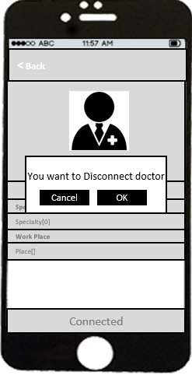

3.1.3.9 Connect doctor

|  |  |  |  |
| --- | --- | --- | --- |
| UC ID and Name: | **UC-1.0.0 – Connect Doctor** | | |
| Created By: | **HungNV** | Date Created: | **16/6/2016** |
| Primary Actor: | **Patient** | Secondary Actors: | N/A |
| Trigger: | Actor navigates to [app]/patient | | |
| Description: | Connect Doctor | | |
| Preconditions: | User access on Login Screen successfully | | |
| Post conditions: | Connect Doctor | | |
| Normal Flow: | |  |  |  | | --- | --- | --- | | **No** | **Actor ‘s events** | **System response** | | 1 | Login to application |  | | 2 |  | Display [home] screen | | 3 | Click “Find doctor” button. |  | | 4 |  | Display [Find doctor] screen | | 5 | Find and choose a doctor |  | | 6 |  | Display [profile doctor] screen | | 7 | Click “Connect” button |  | | 8 |  | A message “You want to connect doctor” will appear | | 9 | Click “OK” button |  | | 10 |  | A message “Connect successful” will appear | | | |
| Alternative Flows: | N/A | | |
| Exceptions: | **N/A** | | |
| Priority: | High. | | |
| Frequency of Use: | High. | | |
| Business Rules: | N/A | | |
| Other Information: | N/A | | |
| Assumptions: | N/A | | |

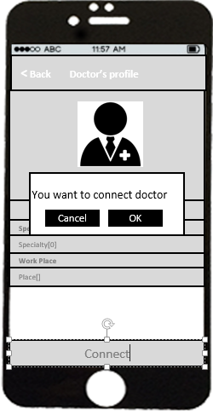

3.1.3.8 Rate

|  |  |  |  |
| --- | --- | --- | --- |
| UC ID and Name: | **UC-1.0.0 – Rate** | | |
| Created By: | **HungNV** | Date Created: | **16/6/2016** |
| Primary Actor: | **Patient** | Secondary Actors: | N/A |
| Trigger: | Actor navigates to [app]/patient | | |
| Description: | Rate for your doctor | | |
| Preconditions: | User access on Login Screen successfully | | |
| Post conditions: | Rate for your doctor | | |
| Normal Flow: | |  |  |  | | --- | --- | --- | | **No** | **Actor ‘s events** | **System response** | | 1 | Login to application |  | | 2 |  | Display [home] screen | | 3 | Click “My doctor” button. |  | | 4 |  | Display [My doctor] screen | | 5 | Choose a doctor |  | | 6 |  | Display [Detail doctor] screen | | 7 | Click “Reviews” button |  | | 8 |  | Show all comment about your doctor | | 9 | Click “Show review” button |  | | 10 |  | Display review of your doctor | | 11 | Click “Rating” button |  | | 12 |  | Display [Rate] screen | | | |
| Alternative Flows: | N/A | | |
| Exceptions: | **N/A** | | |
| Priority: | High. | | |
| Frequency of Use: | High. | | |
| Business Rules: | N/A | | |
| Other Information: | N/A | | |
| Assumptions: | N/A | | |

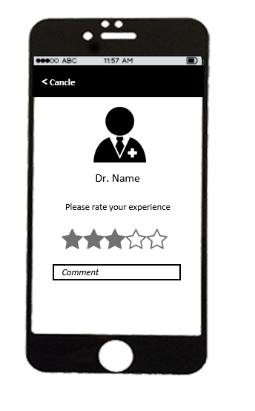

3.1.3.9 Edit profile

|  |  |  |  |
| --- | --- | --- | --- |
| UC ID and Name: | **UC-1.0.0 – Edit profile** | | |
| Created By: | **HungNV** | Date Created: | **16/6/2016** |
| Primary Actor: | **Patient** | Secondary Actors: | N/A |
| Trigger: | Actor navigates to [app]/patient | | |
| Description: | Edit profile | | |
| Preconditions: | User access on Login Screen successfully | | |
| Post conditions: | Edit profile is successfully | | |
| Normal Flow: | |  |  |  | | --- | --- | --- | | **No** | **Actor ‘s events** | **System response** | | 1 | Login to application |  | | 2 |  | Display [home] screen | | 3 | Click “Menu” button. |  | | 4 |  | Display [Menu] tab | | 5 | Click “Profile” button |  | |  |  | Display [Profile] screen | | 6 | Edit information and click “Save” button |  | |  |  | A message “Edit profile is successfully” will appear | | | |
| Alternative Flows: | N/A | | |
| Exceptions: | **Invalid first name: First name can not empty**  A message will appear “First name can not empty”.  **Invalid last name: Last name can not empty**  A message will appear “Last name can not empty”.  **Invalid address: Address can not empty**  A message will appear “Address can not empty”.  **Invalid phone: Phone can not empty**  A message will appear “Phone can not empty”.  **Invalid phone: Phone must be number**  A message will appear “Phone must be number”.  **Invalid phone: Phone numbers is error**  A message will appear “Phone numbers is error”. | | |
| Priority: | High. | | |
| Frequency of Use: | High. | | |
| Business Rules: | N/A | | |
| Other Information: | N/A | | |
| Assumptions: | N/A | | |

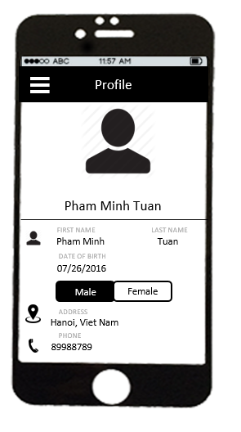

3.1.3.10 View Appointment

|  |  |  |  |
| --- | --- | --- | --- |
| UC ID and Name: | **UC-1.0.0 – View Appointments** | | |
| Created By: | **HungNV** | Date Created: | **16/6/2016** |
| Primary Actor: | **Patient** | Secondary Actors: | N/A |
| Trigger: | Actor navigates to [app]/patient | | |
| Description: | View appointments | | |
| Preconditions: | User access on Login Screen successfully | | |
| Post conditions: | Display appointments and calendar in month | | |
| Normal Flow: | |  |  |  | | --- | --- | --- | | **No** | **Actor ‘s events** | **System response** | | 1 | Login to application |  | | 2 |  | Display [home] screen | | 3 | Click “Appointments” button |  | | 4 |  | Display appointments and calendar in month | | | |
| Alternative Flows: | N/A | | |
| Exceptions: | **N/A** | | |
| Priority: | High. | | |
| Frequency of Use: | High. | | |
| Business Rules: | N/A | | |
| Other Information: | N/A | | |
| Assumptions: | N/A | | |

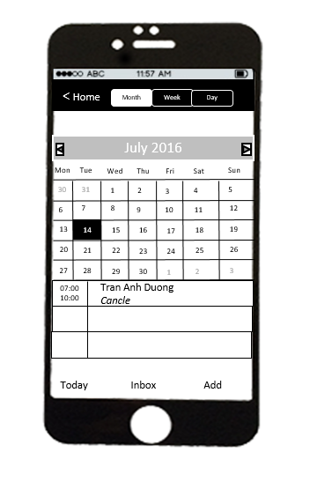

3.1.3.11 Add appointment

|  |  |  |  |
| --- | --- | --- | --- |
| UC ID and Name: | **UC-1.0.0 – Add Appointments** | | |
| Created By: | **HungNV** | Date Created: | **16/6/2016** |
| Primary Actor: | **Patient** | Secondary Actors: | N/A |
| Trigger: | Actor navigates to [app]/patient | | |
| Description: | Add a appointment | | |
| Preconditions: | User access on Login Screen successfully | | |
| Post conditions: | Add appointment is successfully | | |
| Normal Flow: | |  |  |  | | --- | --- | --- | | **No** | **Actor ‘s events** | **System response** | | 1 | Login to application |  | | 2 |  | Display [home] screen | | 3 | Click “Appointments” button |  | | 4 |  | Display appointments and calendar in month | | 5 | Click “Add” button |  | | 6 |  | Display [Add appointment] screen | | 7 | Enter information and click “Create” button |  | | 8 |  | A message “Create done” will appear | | | |
| Alternative Flows: | N/A | | |
| Exceptions: | **Invalid doctor: Need select a doctor** A message “Please select a doctor” will appear  **Invalid time: Time can not empty**  A message “Time can not empty will appear”  **Invalid time: Day can not earlier than current time** A message “Day is earlier than current time” will appear  Invalid content: Content can not empty A message “Content appointment is empty” will appear | | |
| Priority: | High. | | |
| Frequency of Use: | High. | | |
| Business Rules: | N/A | | |
| Other Information: | N/A | | |
| Assumptions: | N/A | | |

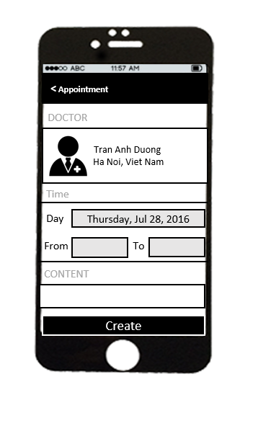

3.1.3.12 View Prescription

|  |  |  |  |
| --- | --- | --- | --- |
| UC ID and Name: | **UC-1.0.0 – View Prescription** | | |
| Created By: | **HungNV** | Date Created: | **16/6/2016** |
| Primary Actor: | **Patient** | Secondary Actors: | N/A |
| Trigger: | Actor navigates to [app]/patient | | |
| Description: | View current prescription | | |
| Preconditions: | User access on Login Screen successfully | | |
| Post conditions: | Display [Current Prescription] screen | | |
| Normal Flow: | |  |  |  | | --- | --- | --- | | **No** | **Actor ‘s events** | **System response** | | 1 | Login to application |  | | 2 |  | Display [home] screen | | 3 | Click “Menu” button. |  | | 4 |  | Display [menu] tab | | 5 | Click “Prescription” button |  | |  |  | Display [Current Prescription] screen | | | |
| Alternative Flows: | N/A | | |
| Exceptions: | N/A | | |
| Priority: | High. | | |
| Frequency of Use: | High. | | |
| Business Rules: | N/A | | |
| Other Information: | N/A | | |
| Assumptions: | N/A | | |

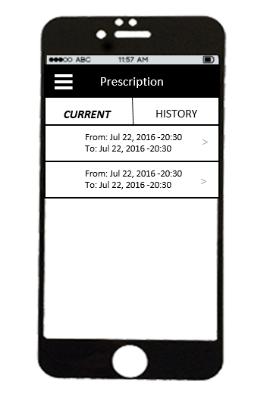

3.1.3.13 Add prescription

|  |  |  |  |
| --- | --- | --- | --- |
| UC ID and Name: | **UC-1.0.0 – Add Prescription** | | |
| Created By: | **HungNV** | Date Created: | **16/6/2016** |
| Primary Actor: | **Patient** | Secondary Actors: | N/A |
| Trigger: | Actor navigates to [app]/patient | | |
| Description: | Add a prescription | | |
| Preconditions: | User access on Login Screen successfully | | |
| Post conditions: | Add prescription is successfully | | |
| Normal Flow: | |  |  |  | | --- | --- | --- | | **No** | **Actor ‘s events** | **System response** | | 1 | Login to application |  | | 2 |  | Display [home] screen | | 3 | Click “Medical record” button. |  | | 4 |  | Display [medical category] screen | | 5 | Choose a medical category |  | | 6 |  | Display [List medical record] screen | | 7 | Choose a medical record |  | | 8 |  | Display [Medical Record] screen | | 9 | Click “Prescription” button |  | | 10 |  | Display [Medical Prescription] screen | | 11 | Click “+” icon |  | | 12 |  | Display [Create prescription] screen | | 13 | Enter information and click “Create” button |  | | 14 |  | A message “Create prescription successful” | | | |
| Alternative Flows: | N/A | | |
| Exceptions: | **Invalid name: Name can not empty** A message “Name can not empty” will appear  **Invalid time: Day can not earlier than current time** A message “Day is earlier than current time” will appear  Invalid content: Content can not empty A message “Content appointment is empty” will appear | | |
| Priority: | High. | | |
| Frequency of Use: | High. | | |
| Business Rules: | N/A | | |
| Other Information: | N/A | | |
| Assumptions: | N/A | | |

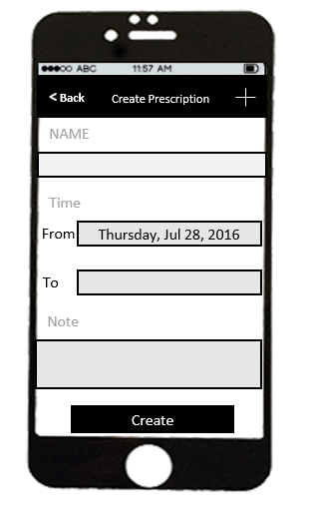

3.1.3.14 Edit prescription

|  |  |  |  |
| --- | --- | --- | --- |
| UC ID and Name: | **UC-1.0.0 – Edit prescription** | | |
| Created By: | **HungNV** | Date Created: | **16/6/2016** |
| Primary Actor: | **Patient** | Secondary Actors: | N/A |
| Trigger: | Actor navigates to [app]/patient | | |
| Description: | Edit prescription | | |
| Preconditions: | User access on Login Screen successfully | | |
| Post conditions: | Edit prescription successfully | | |
| Normal Flow: | |  |  |  | | --- | --- | --- | | **No** | **Actor ‘s events** | **System response** | | 1 | Login to application |  | | 2 |  | Display [home] screen | | 3 | Click “Menu” button. |  | | 4 |  | Display [menu] tab | | 5 | Click “Prescription” button |  | | 6 |  | Display [Current Prescription] screen | | 7 | Choose a prescription |  | | 8 |  | Display [Prescription] screen | | 9 | Edit information and click “Save” button |  | | 10 |  | A message “Save successful” | | | |
| Alternative Flows: | |  |  |  | | --- | --- | --- | | **No** | **Actor ‘s events** | **System response** | | 1 | Login to application |  | | 2 |  | Display [home] screen | | 3 | Click “Medical record” button. |  | | 4 |  | Display [medical category] screen | | 5 | Choose a medical category |  | | 6 |  | Display [List medical record] screen | | 7 | Choose a medical record |  | | 8 |  | Display [Medical Record] screen | | 9 | Click “Prescription” button |  | | 10 |  | Display [Medical Prescription] screen | | 11 | Edit information and click “Save” button |  | | 12 |  | A message “Save successful” will appear | | | |
| Exceptions: | **N/A** | | |
| Priority: | High. | | |
| Frequency of Use: | High. | | |
| Business Rules: | N/A | | |
| Other Information: | N/A | | |
| Assumptions: | N/A | | |
|  |  | | |

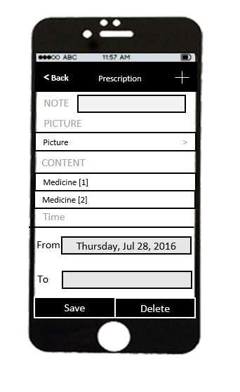

3.1.3.15 Delete prescription

|  |  |  |  |
| --- | --- | --- | --- |
| UC ID and Name: | **UC-1.0.0 – Delete prescription** | | |
| Created By: | **HungNV** | Date Created: | **16/6/2016** |
| Primary Actor: | **Patient** | Secondary Actors: | N/A |
| Trigger: | Actor navigates to [app]/patient | | |
| Description: | Delete prescription | | |
| Preconditions: | User access on Login Screen successfully | | |
| Post conditions: | Delete prescription successfully | | |
| Normal Flow: | |  |  |  | | --- | --- | --- | | **No** | **Actor ‘s events** | **System response** | | 1 | Login to application |  | | 2 |  | Display [home] screen | | 3 | Click “Menu” button. |  | | 4 |  | Display [menu] tab | | 5 | Click “Prescription” button |  | | 6 |  | Display [Current Prescription] screen | | 7 | Choose a prescription |  | | 8 |  | Display [Prescription] screen | | 9 | Click “Delete” button |  | | 10 |  | A message “Delete successful” | | | |
| Alternative Flows: | |  |  |  | | --- | --- | --- | | **No** | **Actor ‘s events** | **System response** | | 1 | Login to application |  | | 2 |  | Display [home] screen | | 3 | Click “Medical record” button. |  | | 4 |  | Display [medical category] screen | | 5 | Choose a medical category |  | | 6 |  | Display [List medical record] screen | | 7 | Choose a medical record |  | | 8 |  | Display [Medical Record] screen | | 9 | Click “Prescription” button |  | | 10 |  | Display [Medical Prescription] screen | | 11 | Click “Delete” button |  | | 12 |  | A message “Delete successful” will appear | | | |
| Exceptions: | **N/A** | | |
| Priority: | High. | | |
| Frequency of Use: | High. | | |
| Business Rules: | N/A | | |
| Other Information: | N/A | | |
| Assumptions: | N/A | | |
|  |  | | |



3.1.3.16 View medical record

|  |  |  |  |
| --- | --- | --- | --- |
| UC ID and Name: | **UC-1.0.0 – View Medical record** | | |
| Created By: | **HungNV** | Date Created: | **16/6/2016** |
| Primary Actor: | **Patient** | Secondary Actors: | N/A |
| Trigger: | Actor navigates to [app]/patient | | |
| Description: | View Medical record | | |
| Preconditions: | User access on Login Screen successfully | | |
| Post conditions: | Show all medical record | | |
| Normal Flow: | |  |  |  | | --- | --- | --- | | **No** | **Actor ‘s events** | **System response** | | 1 | Login to application |  | | 2 |  | Display [home] screen | | 3 | Click “Medical record” button. |  | | 4 |  | Display [Medical category] screen | | 5 | Choose a medical category |  | | 6 |  | Display [Medical record] screen | | | |
| Alternative Flows: | N/A | | |
| Exceptions: | **N/A** | | |
| Priority: | High. | | |
| Frequency of Use: | High. | | |
| Business Rules: | N/A | | |
| Other Information: | N/A | | |
| Assumptions: | N/A | | |

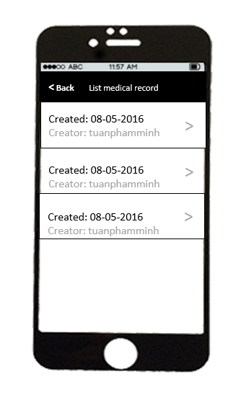

3.1.3.17 Add medical record

|  |  |  |  |
| --- | --- | --- | --- |
| UC ID and Name: | **UC-1.0.0 – Add Medical record** | | |
| Created By: | **HungNV** | Date Created: | **16/6/2016** |
| Primary Actor: | **Patient** | Secondary Actors: | N/A |
| Trigger: | Actor navigates to [app]/patient | | |
| Description: | Add Medical record | | |
| Preconditions: | User access on Login Screen successfully | | |
| Post conditions: | Add medical record successfully | | |
| Normal Flow: | |  |  |  | | --- | --- | --- | | **No** | **Actor ‘s events** | **System response** | | 1 | Login to application |  | | 2 |  | Display [home] screen | | 3 | Click “Medical record” button. |  | | 4 |  | Display [Medical Category] screen | | 5 | Click “+” icon |  | | 6 |  | Display [Add medical record] screen | | 7 | Enter information and click “Create” button |  | | 8 |  | A message “Create successfully” will appear | | | |
| Alternative Flows: | N/A | | |
| Exceptions: | **Invalid Category: Category can not empty**  A message will appear “**Please Select Category**”.  **Invalid Time: Time can not empty**  A message will appear “**Please Select time**”.  **Invalid Doctor: Doctor can not empty**  A message will appear “**Please Select Doctor**”. | | |
| Priority: | High. | | |
| Frequency of Use: | High. | | |
| Business Rules: | N/A | | |
| Other Information: | N/A | | |
| Assumptions: | N/A | | |

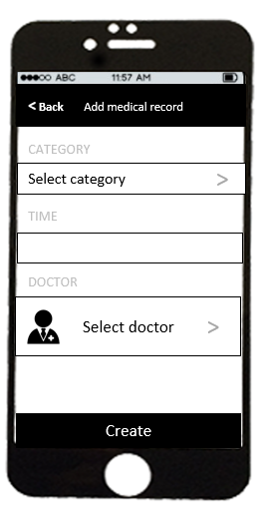

3.1.3.18 Edit medical record

|  |  |  |  |
| --- | --- | --- | --- |
| UC ID and Name: | **UC-1.0.0 – Edit Medical record** | | |
| Created By: | **HungNV** | Date Created: | **16/6/2016** |
| Primary Actor: | **Patient** | Secondary Actors: | N/A |
| Trigger: | Actor navigates to [app]/patient | | |
| Description: | Edit Medical record | | |
| Preconditions: | User access on Login Screen successfully | | |
| Post conditions: | Edit medical record successfully | | |
| Normal Flow: | |  |  |  | | --- | --- | --- | | **No** | **Actor ‘s events** | **System response** | | 1 | Login to application |  | | 2 |  | Display [home] screen | | 3 | Click “Medical record” button. |  | | 4 |  | Display [Medical category] screen | | 5 | Choose medical category |  | | 6 |  | Display [List medical record] screen | | 7 | Choose medical record |  | | 8 |  | Display [medical record] screen | | 9 | Edit information and click “Save” button |  | | 10 |  | A message “Edit successful” will appear and back to [List medical record] screen | | | |
| Alternative Flows: | N/A | | |
| Exceptions: | **N/A** | | |
| Priority: | High. | | |
| Frequency of Use: | High. | | |
| Business Rules: | N/A | | |
| Other Information: | N/A | | |
| Assumptions: | N/A | | |

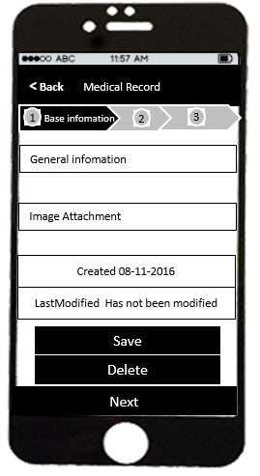

3.1.3.19 Delete medical record

|  |  |  |  |
| --- | --- | --- | --- |
| UC ID and Name: | **UC-1.0.0 – Delete Medical record** | | |
| Created By: | **HungNV** | Date Created: | **16/6/2016** |
| Primary Actor: | **Patient** | Secondary Actors: | N/A |
| Trigger: | Actor navigates to [app]/patient | | |
| Description: | Delete Medical record | | |
| Preconditions: | User access on Login Screen successfully | | |
| Post conditions: | Delete medical record successfully | | |
| Normal Flow: | |  |  |  | | --- | --- | --- | | **No** | **Actor ‘s events** | **System response** | | 1 | Login to application |  | | 2 |  | Display [home] screen | | 3 | Click “Medical record” button. |  | | 4 |  | Display [Medical category] screen | | 5 | Choose medical category |  | | 6 |  | Display [List medical record] screen | | 7 | Choose medical record |  | | 8 |  | Display [medical record] screen | | 9 | Click “Delete” button |  | | 10 |  | A popup “You want to delete medical record” will appear | | 11 | Click “OK” button |  | | 12 |  | A message “Delete successful” will appear and back to [List medical record] screen | | | |
| Alternative Flows: | N/A | | |
| Exceptions: | **N/A** | | |
| Priority: | High. | | |
| Frequency of Use: | High. | | |
| Business Rules: | N/A | | |
| Other Information: | N/A | | |
| Assumptions: | N/A | | |

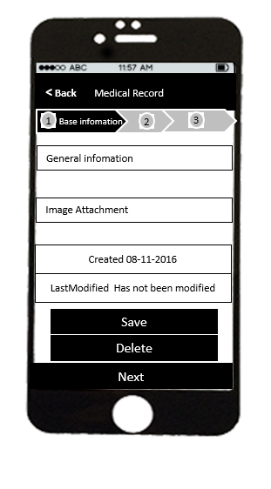

3.1.3.20 View My stats – Heart beat

|  |  |  |  |
| --- | --- | --- | --- |
| UC ID and Name: | **UC-1.0.0 – View My stats – Heartbeat** | | |
| Created By: | **HungNV** | Date Created: | **16/6/2016** |
| Primary Actor: | **Patient** | Secondary Actors: | N/A |
| Trigger: | Actor navigates to [app]/patient | | |
| Description: | View my stats – heartbeat | | |
| Preconditions: | User access on Login Screen successfully | | |
| Post conditions: | Display [Heartbeat] screen | | |
| Normal Flow: | |  |  |  | | --- | --- | --- | | **No** | **Actor ‘s events** | **System response** | | 1 | Login to application |  | | 2 |  | Display [home] screen | | 3 | Click “Menu” button. |  | | 4 |  | Display [menu] tab | | 5 | Click “My stats” button |  | | 6 |  | Display [My stats] screen | | 7 | Click “Heartbeat” button |  | | 8 |  | Display [Heartbeat] | | | |
| Alternative Flows: | N/A | | |
| Exceptions: | **N/A** | | |
| Priority: | High. | | |
| Frequency of Use: | High. | | |
| Business Rules: | N/A | | |
| Other Information: | N/A | | |
| Assumptions: | N/A | | |

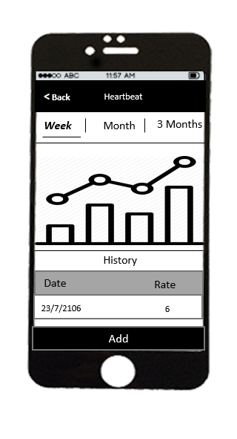

3.1.3.21 Add Heartbeat

|  |  |  |  |
| --- | --- | --- | --- |
| UC ID and Name: | **UC-1.0.0 – My stats – Add Heartbeat** | | |
| Created By: | **HungNV** | Date Created: | **16/6/2016** |
| Primary Actor: | **Patient** | Secondary Actors: | N/A |
| Trigger: | Actor navigates to [app]/patient | | |
| Description: | Add Heartbeat | | |
| Preconditions: | User access on Login Screen successfully | | |
| Post conditions: | Add Heartbeat | | |
| Normal Flow: | |  |  |  | | --- | --- | --- | | **No** | **Actor ‘s events** | **System response** | | 1 | Login to application |  | | 2 |  | Display [home] screen | | 3 | Click “Menu” button. |  | | 4 |  | Display [menu] tab | | 5 | Click “My stats” button |  | |  |  | Display [My stats] screen | | 6 | Click “Heartbeat” button |  | |  |  | Display Weekly statistics heartbeat | | 7 | Click “Add” button |  | |  |  | Display [Add Heartbeat] screen | | 8 | Enter information and Click “ Create” button |  | |  |  | A message “Create successfully” appear | | | |
| Alternative Flows: | N/A | | |
| Exceptions: | **Invalid Date: Date can not empty**  A message will appear “Date can not empty”.  **Invalid Value: Value must be numbers**  A message will appear “Value can not empty”. | | |
| Priority: | High. | | |
| Frequency of Use: | High. | | |
| Business Rules: | N/A | | |
| Other Information: | N/A | | |
| Assumptions: | N/A | | |

3.1.3.22 Edit Heartbeat

|  |  |  |  |
| --- | --- | --- | --- |
| UC ID and Name: | **UC-1.0.0 – My stats – Edit Heartbeat** | | |
| Created By: | **HungNV** | Date Created: | **16/6/2016** |
| Primary Actor: | **Patient** | Secondary Actors: | N/A |
| Trigger: | Actor navigates to [app]/patient | | |
| Description: | Edit Heartbeat | | |
| Preconditions: | User access on Login Screen successfully | | |
| Post conditions: | Edit Heartbeat successful | | |
| Normal Flow: | |  |  |  | | --- | --- | --- | | **No** | **Actor ‘s events** | **System response** | | 1 | Login to application |  | | 2 |  | Display [home] screen | | 3 | Click “Menu” button. |  | | 4 |  | Display [menu] tab | | 5 | Click “My stats” button |  | |  |  | Display [My stats] screen | | 6 | Click “Heartbeat” button |  | |  |  | Display Weekly statistics heartbeat | | 7 | Click record want to edit |  | |  |  | Display [Edit Heartbeat] screen | | 8 | Click “ Save” button |  | |  |  | A message “Save successfully” appear | | | |
| Alternative Flows: | N/A | | |
| Exceptions: | **Invalid Rate: Rate must be numbers**  A message will appear “**Rate must be numbers**”.  **Invalid Rate: Rate can not empty**  A message will appear “**Rate can not empty**”. | | |
| Priority: | High. | | |
| Frequency of Use: | High. | | |
| Business Rules: | N/A | | |
| Other Information: | N/A | | |
| Assumptions: | N/A | | |

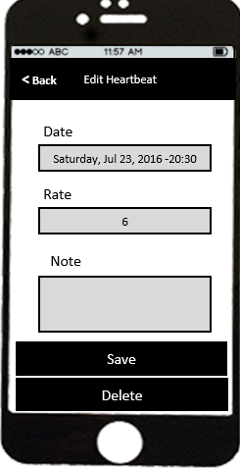

3.1.3.23 Delete Heartbeat

|  |  |  |  |
| --- | --- | --- | --- |
| UC ID and Name: | **UC-1.0.0 – My stats – Delete Heartbeat** | | |
| Created By: | **HungNV** | Date Created: | **16/6/2016** |
| Primary Actor: | **Patient** | Secondary Actors: | N/A |
| Trigger: | Actor navigates to [app]/patient | | |
| Description: | Delete heartbeat | | |
| Preconditions: | User access on Login Screen successfully | | |
| Post conditions: | Delete Heartbeat | | |
| Normal Flow: | |  |  |  | | --- | --- | --- | | **No** | **Actor ‘s events** | **System response** | | 1 | Login to application |  | | 2 |  | Display [home] screen | | 3 | Click “Menu” button. |  | | 4 |  | Display [menu] tab | | 5 | Click “My Stats” button |  | |  |  | Display [My Stats] screen | | 6 | Click “Heartbeat” button |  | |  |  | Display Weekly statistics heartbeat | | 7 | Click record want to delete |  | |  |  | Display [Edit Heartbeat] screen | | 8 | Click “ Delete” button |  | |  |  | A message “Want to delete record” appear | | 9 | Click “Yes” button |  | |  |  | A message “Delete successfully” appear | | | |
| Alternative Flows: | N/A | | |
| Exceptions: | **N/A** | | |
| Priority: | High. | | |
| Frequency of Use: | High. | | |
| Business Rules: | N/A | | |
| Other Information: | N/A | | |
| Assumptions: | N/A | | |



3.1.3.24 View My Stats – Blood Pressure

|  |  |  |  |
| --- | --- | --- | --- |
| UC ID and Name: | **UC-1.0.0 – View Blood Pressure** | | |
| Created By: | **HungNV** | Date Created: | **16/6/2016** |
| Primary Actor: | **Patient** | Secondary Actors: | N/A |
| Trigger: | Actor navigates to [app]/patient | | |
| Description: | View Blood Pressure | | |
| Preconditions: | User access on Login Screen successfully | | |
| Post conditions: | Display Weekly statistics Blood Pressure | | |
| Normal Flow: | |  |  |  | | --- | --- | --- | | **No** | **Actor ‘s events** | **System response** | | 1 | Login to application |  | | 2 |  | Display [home] screen | | 3 | Click “Menu” button. |  | | 4 |  | Display [menu] tab | | 5 | Click “My Stats” button |  | |  |  | Display [My Stats] screen | | 6 | Click “Blood Pressure” button |  | |  |  | Display Weekly statistics Blood Pressure | | | |
| Alternative Flows: | N/A | | |
| Exceptions: | **N/A** | | |
| Priority: | High. | | |
| Frequency of Use: | High. | | |
| Business Rules: | N/A | | |
| Other Information: | N/A | | |
| Assumptions: | N/A | | |

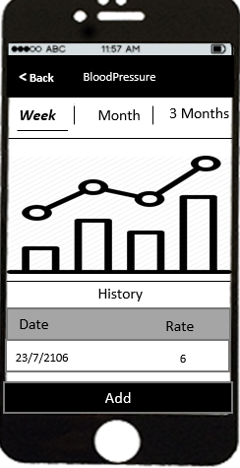

3.1.3.25 Add Blood Pressure

|  |  |  |  |
| --- | --- | --- | --- |
| UC ID and Name: | **UC-1.0.0 – My stats – Add Blood Pressure** | | |
| Created By: | **HungNV** | Date Created: | **16/6/2016** |
| Primary Actor: | **Patient** | Secondary Actors: | N/A |
| Trigger: | Actor navigates to [app]/patient | | |
| Description: | Add Blood pressure | | |
| Preconditions: | User access on Login Screen successfully | | |
| Post conditions: | Add Blood Pressure successful | | |
| Normal Flow: | |  |  |  | | --- | --- | --- | | **No** | **Actor ‘s events** | **System response** | | 1 | Login to application |  | | 2 |  | Display [home] screen | | 3 | Click “Menu” button. |  | | 4 |  | Display [menu] tab | | 5 | Click “My stats” button |  | |  |  | Display [My stats] screen | | 6 | Click “Blood Pressure” button |  | |  |  | Display Weekly statistics Blood Pressure | | 7 | Click “Add” button |  | |  |  | Display [Add Blood Pressure] screen | | 8 | Click “ Create” button |  | |  |  | A message “Create successfully” appear | | | |
| Alternative Flows: | N/A | | |
| Exceptions: | **Invalid Date: Date can not empty**  A message will appear “Date can not empty”.  **Invalid Rate: Rate must be numbers**  A message will appear “**Rate must be numbers**”.  **Invalid Rate: Rate can not empty**  A message will appear “**Rate can not empty**”. | | |
| Priority: | High. | | |
| Frequency of Use: | High. | | |
| Business Rules: | N/A | | |
| Other Information: | N/A | | |
| Assumptions: | N/A | | |

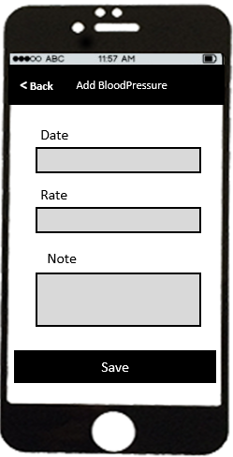

3.1.3.26 Edit Blood Pressure

|  |  |  |  |
| --- | --- | --- | --- |
| UC ID and Name: | **UC-1.0.0 – My stats– Edit Blood Pressure** | | |
| Created By: | **HungNV** | Date Created: | **16/6/2016** |
| Primary Actor: | **Patient** | Secondary Actors: | N/A |
| Trigger: | Actor navigates to [app]/patient | | |
| Description: | Edit Blood Pressure | | |
| Preconditions: | User access on Login Screen successfully | | |
| Post conditions: | Edit Blood Pressure successful | | |
| Normal Flow: | |  |  |  | | --- | --- | --- | | **No** | **Actor ‘s events** | **System response** | | 1 | Login to application |  | | 2 |  | Display [home] screen | | 3 | Click “Menu” button. |  | | 4 |  | Display [menu] tab | | 5 | Click “My stats” button |  | |  |  | Display [My stats] screen | | 6 | Click “Blood Pressure” button |  | |  |  | Display Weekly statistics Blood Pressure | | 7 | Click record want to edit |  | |  |  | Display [Edit Blood Pressure] screen | | 8 | Click “ Save” button |  | |  |  | A message “Save successfully” appear | | | |
| Alternative Flows: | N/A | | |
| Exceptions: | **Invalid Rate: Rate must be numbers**  A message will appear “**Rate must be numbers**”.  **Invalid Rate: Rate can not empty**  A message will appear “**Rate can not empty**”. | | |
| Priority: | High. | | |
| Frequency of Use: | High. | | |
| Business Rules: | N/A | | |
| Other Information: | N/A | | |
| Assumptions: | N/A | | |

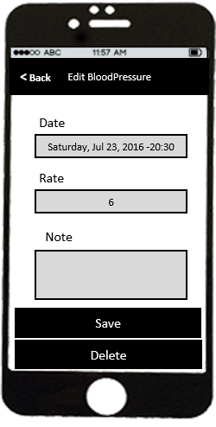

3.1.3.27 Delete Blood Pressure

|  |  |  |  |
| --- | --- | --- | --- |
| UC ID and Name: | **UC-1.0.0 – My stats – Delete Blood Pressure** | | |
| Created By: | **HungNV** | Date Created: | **16/6/2016** |
| Primary Actor: | **Patient** | Secondary Actors: | N/A |
| Trigger: | Actor navigates to [app]/patient | | |
| Description: | Delete Blood Pressure | | |
| Preconditions: | User access on Login Screen successfully | | |
| Post conditions: | Delete Blood Pressure | | |
| Normal Flow: | |  |  |  | | --- | --- | --- | | **No** | **Actor ‘s events** | **System response** | | 1 | Login to application |  | | 2 |  | Display [home] screen | | 3 | Click “Menu” button. |  | | 4 |  | Display [menu] tab | | 5 | Click “My Stats” button |  | |  |  | Display [My Stats] screen | | 6 | Click “Blood Pressure” button |  | |  |  | Display Weekly statistics Blood Pressure | | 7 | Click record want to delete |  | |  |  | Display [Edit Blood Pressure] screen | | 8 | Click “ Delete” button |  | |  |  | A message “Want to delete Blood Pressure” appear | | 9 | Click “Yes” button |  | |  |  | A message “Delete successfully” appear | | | |
| Alternative Flows: | N/A | | |
| Exceptions: | **N/A** | | |
| Priority: | High. | | |
| Frequency of Use: | High. | | |
| Business Rules: | N/A | | |
| Other Information: | N/A | | |
| Assumptions: | N/A | | |



3.1.3.28 View My stats – Blood Sugar

|  |  |  |  |
| --- | --- | --- | --- |
| UC ID and Name: | **UC-1.0.0 – View Blood Sugar** | | |
| Created By: | **HungNV** | Date Created: | **16/6/2016** |
| Primary Actor: | **Patient** | Secondary Actors: | N/A |
| Trigger: | Actor navigates to [app]/patient | | |
| Description: | View Blood Sugar | | |
| Preconditions: | User access on Login Screen successfully | | |
| Post conditions: | Display Weekly statistics Blood Sugar | | |
| Normal Flow: | |  |  |  | | --- | --- | --- | | **No** | **Actor ‘s events** | **System response** | | 1 | Login to application |  | | 2 |  | Display [home] screen | | 3 | Click “Menu” button. |  | | 4 |  | Display [menu] tab | | 5 | Click “My Stats” button |  | |  |  | Display [My Stats] screen | | 6 | Click “Blood Sugar” button |  | |  |  | Display Weekly statistics Blood Sugar | | | |
| Alternative Flows: | N/A | | |
| Exceptions: | **N/A** | | |
| Priority: | High. | | |
| Frequency of Use: | High. | | |
| Business Rules: | N/A | | |
| Other Information: | N/A | | |
| Assumptions: | N/A | | |

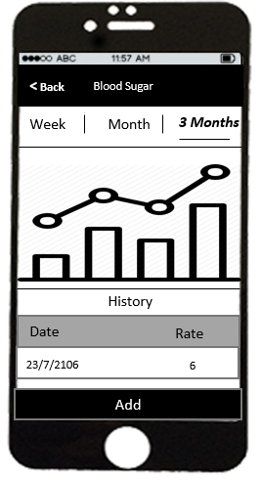

3.1.3.29 Add Blood Sugar

|  |  |  |  |
| --- | --- | --- | --- |
| UC ID and Name: | **UC-1.0.0 – My stats – Add Blood Sugar** | | |
| Created By: | **HungNV** | Date Created: | **16/6/2016** |
| Primary Actor: | **Patient** | Secondary Actors: | N/A |
| Trigger: | Actor navigates to [app]/patient | | |
| Description: | Add Blood Sugar | | |
| Preconditions: | User access on Login Screen successfully | | |
| Post conditions: | Add Blood Sugar successful | | |
| Normal Flow: | |  |  |  | | --- | --- | --- | | **No** | **Actor ‘s events** | **System response** | | 1 | Login to application |  | | 2 |  | Display [home] screen | | 3 | Click “Menu” button. |  | | 4 |  | Display [menu] tab | | 5 | Click “My stats” button |  | |  |  | Display [My stats] screen | | 6 | Click “Blood Sugar” button |  | |  |  | Display Weekly statistics Blood Sugar | | 7 | Click “Add” button |  | |  |  | Display [Add Blood Sugar] screen | | 8 | Click “ Create” button |  | |  |  | A message “Create successfully” appear | | | |
| Alternative Flows: | N/A | | |
| Exceptions: | **Invalid Date: Date can not empty**  A message will appear “Date can not empty”.  **Invalid Rate: Rate must be numbers**  A message will appear “**Rate must be numbers**”.  **Invalid Rate: Rate can not empty**  A message will appear “**Rate can not empty**”. | | |
| Priority: | High. | | |
| Frequency of Use: | High. | | |
| Business Rules: | N/A | | |
| Other Information: | N/A | | |
| Assumptions: | N/A | | |

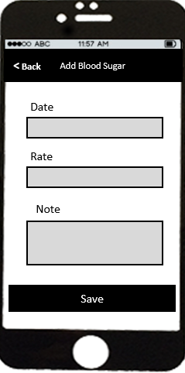

3.1.3.30 Edit Blood Sugar

|  |  |  |  |
| --- | --- | --- | --- |
| UC ID and Name: | **UC-1.0.0 – My stats– Edit Blood Sugar** | | |
| Created By: | **HungNV** | Date Created: | **16/6/2016** |
| Primary Actor: | **Patient** | Secondary Actors: | N/A |
| Trigger: | Actor navigates to [app]/patient | | |
| Description: | Edit Blood Sugar | | |
| Preconditions: | User access on Login Screen successfully | | |
| Post conditions: | Edit Blood Sugar successful | | |
| Normal Flow: | |  |  |  | | --- | --- | --- | | **No** | **Actor ‘s events** | **System response** | | 1 | Login to application |  | | 2 |  | Display [home] screen | | 3 | Click “Menu” button. |  | | 4 |  | Display [menu] tab | | 5 | Click “My stats” button |  | |  |  | Display [My stats] screen | | 6 | Click “Blood Sugar” button |  | |  |  | Display Weekly statistics Blood Sugar | | 7 | Click record want to edit |  | |  |  | Display [Edit Blood Sugar] screen | | 8 | Click “ Save” button |  | |  |  | A message “Save successfully” appear | | | |
| Alternative Flows: | N/A | | |
| Exceptions: | **Invalid Rate: Rate must be numbers**  A message will appear “**Rate must be numbers**”.  **Invalid Rate: Rate can not empty**  A message will appear “**Rate can not empty**”. | | |
| Priority: | High. | | |
| Frequency of Use: | High. | | |
| Business Rules: | N/A | | |
| Other Information: | N/A | | |
| Assumptions: | N/A | | |

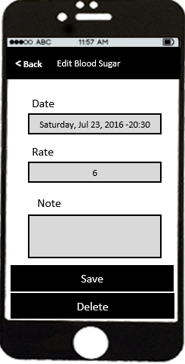

3.1.3.31 Delete Blood Sugar

|  |  |  |  |
| --- | --- | --- | --- |
| UC ID and Name: | **UC-1.0.0 – My stats – Delete Blood Sugar** | | |
| Created By: | **HungNV** | Date Created: | **16/6/2016** |
| Primary Actor: | **Patient** | Secondary Actors: | N/A |
| Trigger: | Actor navigates to [app]/patient | | |
| Description: | Delete Blood Sugar | | |
| Preconditions: | User access on Login Screen successfully | | |
| Post conditions: | Delete Blood Sugar | | |
| Normal Flow: | |  |  |  | | --- | --- | --- | | **No** | **Actor ‘s events** | **System response** | | 1 | Login to application |  | | 2 |  | Display [home] screen | | 3 | Click “Menu” button. |  | | 4 |  | Display [menu] tab | | 5 | Click “My Stats” button |  | |  |  | Display [My Stats] screen | | 6 | Click “Blood Sugar” button |  | |  |  | Display Weekly statistics Blood Sugar | | 7 | Click record want to delete |  | |  |  | Display [Edit Blood Sugar] screen | | 8 | Click “ Delete” button |  | |  |  | A message “Want to delete Blood Sugar” appear | | 9 | Click “Yes” button |  | |  |  | A message “Delete successfully” appear | | | |
| Alternative Flows: | N/A | | |
| Exceptions: | **N/A** | | |
| Priority: | High. | | |
| Frequency of Use: | High. | | |
| Business Rules: | N/A | | |
| Other Information: | N/A | | |
| Assumptions: | N/A | | |

